Guidance note on border crossing records in analogue tachographs
Issue: Manual inclusion of border crossing information in an analogue tachograph.
Legal basis: Article 34(6), paragraph (f) of Regulation (EU) No 165/2014.
Approach to be followed: Article 34(6) paragraph (f) of Regulation (EU) No 165/2014 as amended by Regulation (EU) No 2020/1054 sets out the new obligation for the driver of a vehicle fitted with an analogue tachograph to manually enter in the record sheet of the tachograph the symbol of the country that the driver enters after crossing the border of a Member State. The symbol must be written at the beginning of the driver’s first stop in that Member State (which must be made at the nearest possible stopping place at or after the border), or, when the crossing of the border takes place on a ferry or train, at the port or station of arrival.
Due to the reduced space that remains available on the record sheet after the automatic records on driver’s activity and vehicle speed have been made, the addition of handwritten information by the driver in a way that can be clearly read and understood may be a difficult task. Moreover, adding information manually in certain places of the record sheet may lead to its damage.
The purpose of this guidance note is therefore to indicate where exactly in the record sheet the country symbol should be added, in order to ensure a common approach to implementing the obligation of recording border crossing in analogue tachographs and to prevent a possible damage of the record sheet. Annex A and B of this guidance refer to the manual entries of border crossings in cases of analogue tachographs, whereas Annex C recalls the nation codes to be used as country symbols.
Option 1: under the inner time dial of the record sheet.
Whenever possible, the country symbol should be written under the inner time dial of the record sheet, just underneath the time at which the vehicle was stopped after crossing the border or arrived at the port or station when the crossing of the border takes place on a ferry or train (see Annex A, Figure 1). Where a reference line marks the opening of the hatchet of the tachograph by the driver for the purpose of inserting this manual entry, the country code should therefore be placed under this reference line (see Annex A, Figure 2). This solution allows to minimise the space taken by the border crossing information, since the time of the border crossing is already provided in the time dial. In addition, given that the record sheet features a standard place for displaying the date, it is not necessary either that the driver writes the date of the border crossing.
Annex A provides a clear example of how border crossings should be entered in the record sheet in this case.
Option 2 (if Option 1 is not possible): between the inner and outer time dials of the record sheet.
Only if the space provided in the area described in Option 1 is not sufficient or unavailable for a manual entry of the border crossing, the manual entry is to be inserted between the inner and outer time dials of the disc. The precise location should be to the left of the reference line, without damaging the existing or future recording.
Annex B provides a visualisation of the acceptable area where border crossings should be entered manually in this case.
Option 3 (if Options 1 & 2 are not possible): on the rear side of the analogue disc.
Only as a last resort, if the space available is not sufficient on the front side of the disc for a manual entry, the manual inscription should be included on the back of the disc, and should also include the time of border crossing and the signature of the driver.

Annex A – Manual entry of border crossing in Option 1

Figure 1 – Border crossings with the codes “B” (Belgium) and “D” (Germany) handwritten in the suitable area of the record sheet
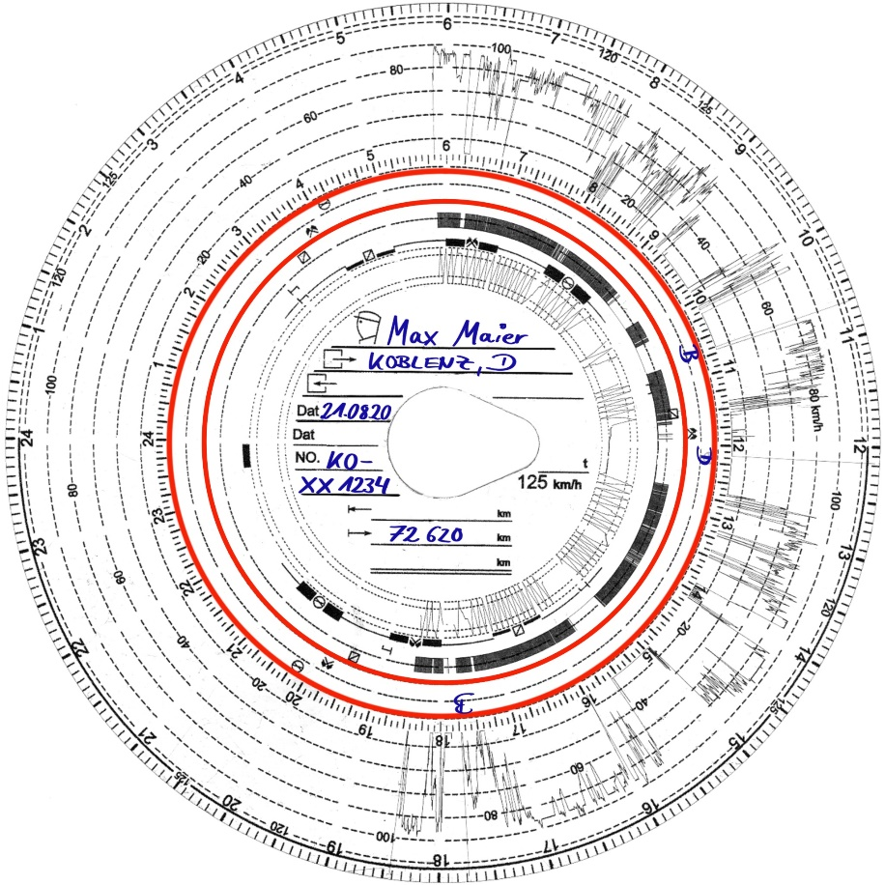
Figure 2 – Detail of the manual record
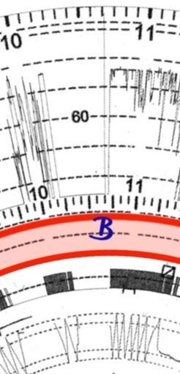

Annex B – Manual entry of border crossing in Option 2
Figure 3 –Suitable additional area of the record sheet to place the manual entry

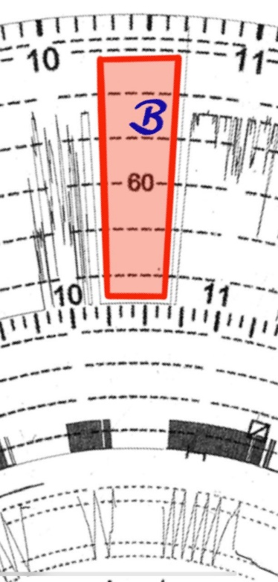
Note: the entries must be placed to the left of the reference line without damaging existing and future recording.
Annex C – Table of nation codes to be used for the manual entry on the analogue tachograph
Country | Nation Alpha Code | Country | Nation Alpha Code
Albania | AL | Malta | M
Andorra | AND | Moldova | MD
Armenia | ARM | Monaco | MC
Austria | A | Montenegro | MNE
Azerbaijan | AZ | Netherlands | NL
Belarus | BY | North Macedonia | MK
Belgium | B | Norway | N
Bosnia Herzegovina | BIH | Poland | PL
Bulgaria | BG | Portugal | P
Croatia | HR | Romania | RO
Cyprus | CY | Russia | RUS
Czech Republic | CZ | San Marino | RSM
Denmark | DK | Serbia | SRB
Estonia | EST | Slovakia | SK
Faroe Islands | FO | Slovenia | SLO
Finland | FIN | Spain | E
France | F | Sweden | S
Georgia | GE | Switzerland | CH
Germany | D | Tajikistan | TJ
Greece | GR | Turkey | TR
Hungary | H | Turkmenistan | TM
Iceland | IS | Ukraine | UA
Ireland | IRL | United Kingdom | UK
Italy | I | Uzbekistan | UZ
Kazakhstan | KZ | Vatican City | V
Latvia | LV | Reserved for Future Use | RFU
Liechtenstein | FL | European Community | EC
Lithuania | LT | Rest of Europe | EUR
Luxembourg | L | Rest of the World | WLD

Regulation (EU) No 165/2014 of the European Parliament and of the Council of 4 February 2014 on tachographs in road transport, repealing Council Regulation (EEC) No 3821/85 on recording equipment in road transport and amending Regulation (EC) No 561/2006 of the European Parliament and of the Council on the harmonisation of certain social legislation relating to road transport Text with EEA relevance (OJ L 60, 28.2.2014, p. 1).
Regulation (EU) 2020/1054 of the European Parliament and of the Council of 15 July 2020 amending Regulation (EC) No 561/2006 as regards minimum requirements on maximum daily and weekly driving times, minimum breaks and daily and weekly rest periods and Regulation (EU) No 165/2014 as regards positioning by means of tachographs (OJ L 249, 31.7.2020, p. 1).
As set out by the Joint Research Centre: Digital Tachograph Nation Codes (europa.eu)

